|  |  |
| --- | --- |
| File:COMSATS new logo.jpg - Wikimedia Commons  Programming Fundamentals  Lab Assignment 04 | **submitted by:**  **Shahzaneer Ahmed**  **registration number:**  **sp21-bcs-087**  **submitted to:**  **Mr. rizwan rashid**  **date of submission:**  **december 29, 2021** |

Question 1

# Source Code

*//------------SHAHZANEER AHMED------------------------  
//----------------SP21-BCS-087------------------------  
//------------Lab Assignment 04-----------------------  
  
//QUESTION #1 (CLO-3)  
//  
// Write a Java program to keep accepting names and marks of students from user until a negative number is  
// entered against marks.  
// Save this data in a text file having name ‘students.txt’.  
  
import java.io.File*;  
*import java.io.FileWriter*;  
*import java.io.IOException*;  
*import java.util.ArrayList*;  
*import java.util.Scanner*;  
  
*public class Question1* {  
 *public static void* main(*String*[] *args*) {  
 *Scanner* input = *new* Scanner(*System*.in);  
*// arraylists are resizeable and highly manageable  
 ArrayList*<*String*> Students = *new* ArrayList<>();  
 *ArrayList*<*Integer*> Marks = *new* ArrayList<>();  
  
*// implementing the logic of problem  
 int* n = 0;  
 *String* name;  
 *do*{  
 *System*.out.println("Enter the name of Student : ");  
 name = input.nextLine();  
 Students.add(name);  
  
 *System*.out.println("Enter the marks : ");  
 n = input.nextInt();  
 input.nextLine(); *//yeh next overflow line ko consume krlega!* Marks.add(n);  
  
 }*while* (n>0);  
*// file creation  
 File* myFile = *new* File("students.txt");  
 *try* {  
 myFile.createNewFile();  
 } *catch* (*IOException e*) {  
 *e*.printStackTrace();  
 }  
 *String* data="";  
 *for* (*int* i=0; i<Students.size()-1;i++){  
*// System.out.printf("%s || %d\n", Students.get(i), Marks.get(i));* data+= *String*.*format*("%s:%d\n", Students.get(i), Marks.get(i));  
  
 }  
  
 *try* {  
 *FileWriter* myFileWriter = *new* FileWriter("students.txt");  
 myFileWriter.write(data);  
 myFileWriter.close();  
 } *catch* (*IOException e*) {  
 *e*.printStackTrace();  
 }  
  
  
  
 }  
}

# Output

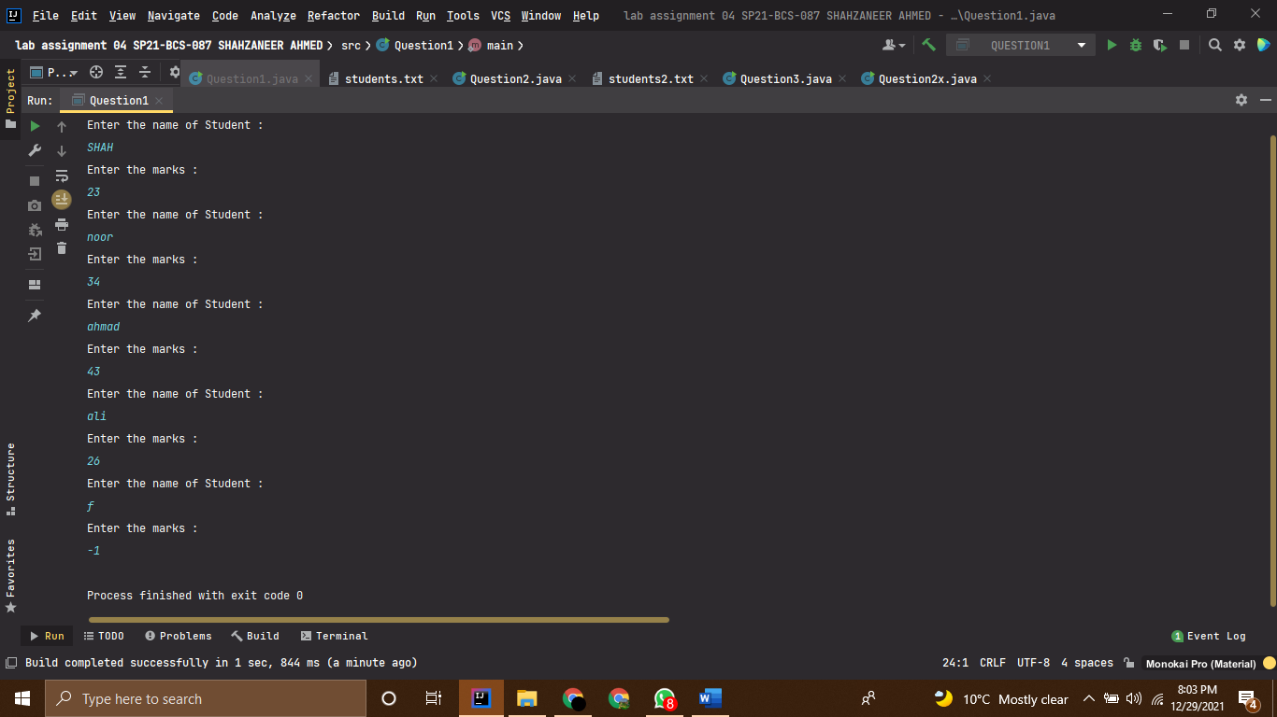

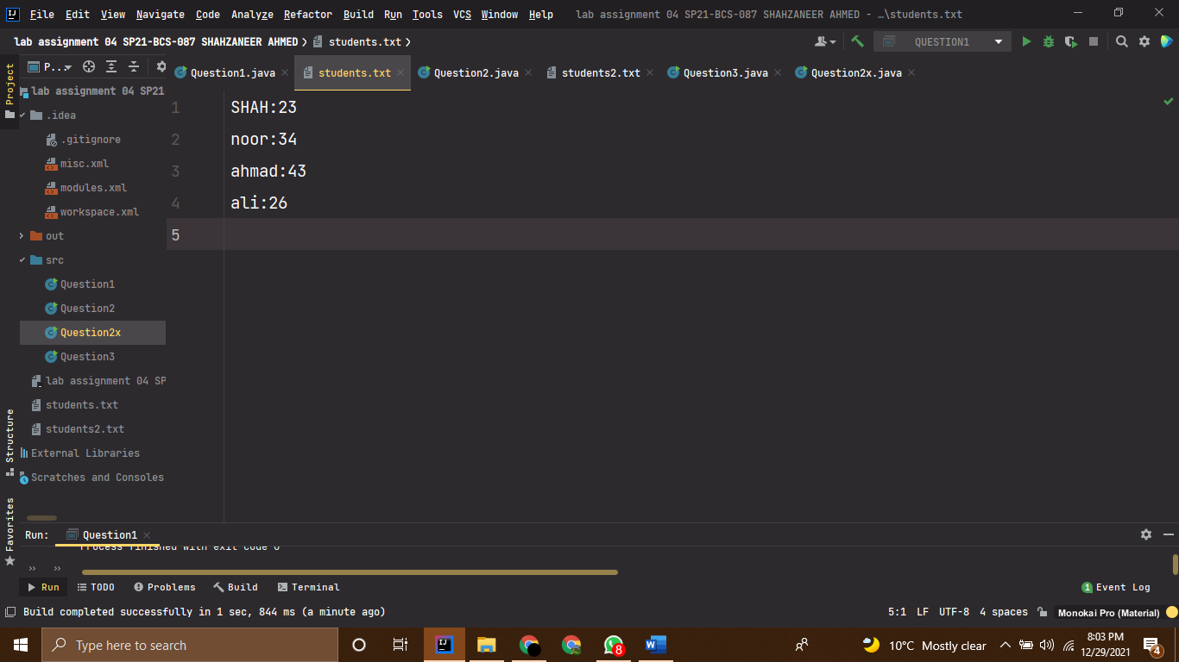

Question 2

# Source Code

*//------------SHAHZANEER AHMED------------------------  
//----------------SP21-BCS-087------------------------  
//------------Lab Assignment 04-----------------------  
  
//QUESTION #2 (CLO-3)  
//  
// Write another program to read all the data from the file ‘students.txt’ created in Q1 above  
// . Display this data in descending order according to their marks.  
  
import java.io.File*;  
*import java.io.FileNotFoundException*;  
*import java.io.FileWriter*;  
*import java.io.IOException*;  
*import java.util.ArrayList*;  
*import java.util.Scanner*;  
  
*public class Question2* {  
 *public static void* main(*String*[] *args*) {  
 *Scanner* input = *new* Scanner(*System*.in);  
*// arraylists are resizeable and highly manageable  
 ArrayList*<*String*> Students = *new* ArrayList<>();  
 *ArrayList*<*Integer*> Marks = *new* ArrayList<>();  
  
*// implementing the logic of problem  
 int* n = 0;  
 *String* name;  
 *do*{  
 *System*.out.println("Enter the name of Student : ");  
 name = input.nextLine();  
 Students.add(name);  
 *System*.out.println("Enter the marks : ");  
 n = input.nextInt();  
 input.nextLine(); *// it will consume the next overflow line!* Marks.add(n);  
  
 }*while* (n>0);  
*// file creation  
 File* myFile = *new* File("students2.txt");  
 *try* {  
 myFile.createNewFile();  
 } *catch* (*IOException e*) {  
 *e*.printStackTrace();  
 }  
*//now making arrays of arraylists for sorting them in the manner of ascending to descending marks  
 int* sizeOfmarks = Marks.size();  
 *int* [] marks = *new int*[sizeOfmarks];  
 *for*(*int* i = 0; i<Marks.size();i++){  
 marks[i]= Marks.get(i);  
 }  
  
 *int* sizeOfStudents = Students.size();  
 *String* [] students = *new* String [sizeOfStudents];  
 *for*(*int* i=0; i<Students.size();i++){  
 students[i]= Students.get(i);  
 }  
*// array sorted in ascending to descending manner!  
 sortingArrays*(marks,students);  
  
  
  
  
 *String* data="";  
 *for* (*int* i=0; i<marks.length-1;i++){  
*// System.out.printf("%s || %d\n", Students.get(i), Marks.get(i));* data+= *String*.*format*("%s:%d\n",students[i],marks[i]);  
  
 }  
  
 *try* {  
 *FileWriter* myFileWriter = *new* FileWriter("students2.txt");  
 myFileWriter.write(data);  
 myFileWriter.close();  
 } *catch* (*IOException e*) {  
 *e*.printStackTrace();  
 }  
  
*// fetching (reading) the file on console  
 try* {  
 *Scanner* sc = *new* Scanner(myFile);  
 *while*(sc.hasNextLine()){  
 *String* readData = sc.nextLine();  
 *System*.out.println(readData);  
 }  
 } *catch* (*FileNotFoundException e*) {  
 *e*.printStackTrace();  
 }  
  
  
 }  
 *public static void* sortingArrays(*int* [] *arr* ,*String* [] *strArr*){  
 *for* (*int* i = 0; i< *arr*.length;i++){  
 *for*(*int* j=i+1; j<*arr*.length;j++){  
 *if*(*arr*[i]<*arr*[j]){  
*// swapping  
 int* temp = *arr*[i];  
 *arr*[i] = *arr*[j];  
 *arr*[j] = temp;  
  
*// swapping the strArray  
 String* tempStr = *strArr*[i];  
 *strArr*[i] = *strArr*[j];  
 *strArr*[j] = tempStr;  
  
 }  
 }  
 }  
  
  
  
 }  
  
}

# Output

Question 3

# Source Code

*//------------SHAHZANEER AHMED------------------------  
//----------------SP21-BCS-087------------------------  
//------------Lab Assignment 04-----------------------  
  
//QUESTION #3 (CLO-3)  
//  
// Suppose the weekly hours for all employees are stored in a two-dimensional array. Each row records an employee’s seven-day work  
// hours with seven columns. For example, the following array stores the work hours for eight employees.  
// Write a program that displays employees and their total hours.  
import java.util.Scanner*;  
*public class Question3* {  
 *public static void* main(*String*[] *args*) {  
 *Scanner* input = *new* Scanner(*System*.in);  
 *int* [][] employeesAndWorkHoursInWeek = {  
 {0,2,4,3,4,5,8,8}  
 ,{1,7,3,4,3,3,4,4}  
 ,{2,3,3,4,3,3,4,4}  
 ,{3,9,3,4,7,3,4,1}  
 ,{4,3,5,4,3,6,3,8}  
 ,{5,3,4,4,6,3,4,4}  
 ,{6,3,7,4,8,3,8,4}  
 ,{7,6,3,5,9,2,7,9}  
 };  
  
 *for*(*int* i = 0; i<8;i++){  
 *int* totalhours = *totalWorkHours*(employeesAndWorkHoursInWeek,i);  
  
 *System*.out.printf("The total work hours of employee %d are %d\n",i,totalhours);  
  
  
 }  
  
  
 }  
  
  
 *public static int* totalWorkHours (*int* [][] *arr*,*int targetedRow*){  
 *int* total = 0;  
 *for*(*int* i = 0; i<*targetedRow*+1;i++){  
 *for*(*int* j= 1; j<*arr*[i].length;j++){  
 *if*(i==*targetedRow*){  
 total+=*arr*[i][j];  
 }  
 }  
 }  
 *return* total;  
 }  
}

# Output

